**Child comfort**

Flat seating surface

-promotes good posture which is essential for a child to learn from a young age

-helps develop balancing reactions, becoming more stable

-”proper pelvic position”, the determining factor regarding proper posture, having poor pelvic position causes things such as back pain

-Allow the seating to be able to switch between upright and rest with ease

-reclined flat seat to allow for different angles for a more relaxing positon

-

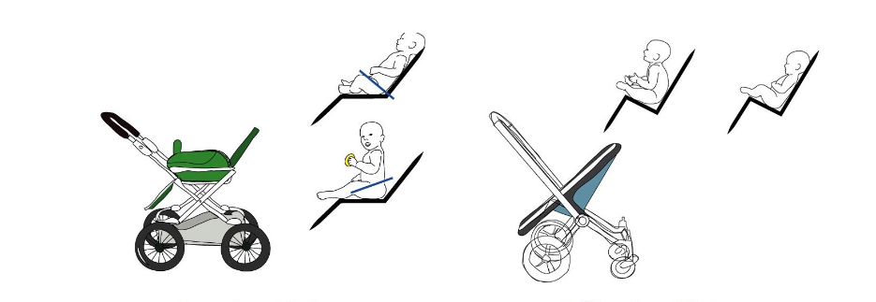

Good seating arrangement vs bad seating arrangement.

*Ergonomic strollers – confusion in definition*. Learn to Move. (n.d.). https://www.learntomove.se/en/project/ergonomiska-barnvagnar-definitionsforvirring/#:~:text=The%20key%20to%20sitting%20upright,from%20the%20front%20or%20back.

-seats such as the common “hammock” style seat are actually an example of poor pelvic position

-a more firm seat with support is more ergonomically sound then a hammock seat

-it raises concerns to posture, support and positioning

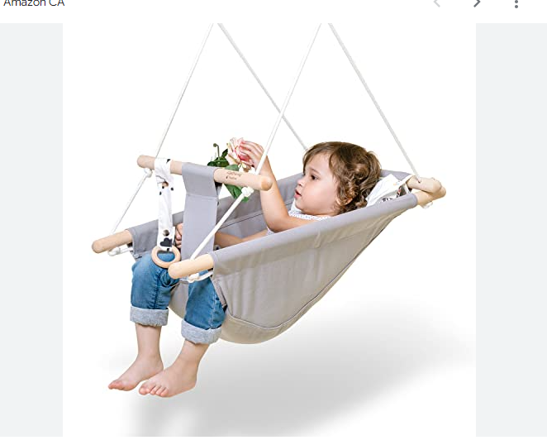

Seat material

Seat padding ensures baby is comfortable

(Yee yin covers material research)

Adjustable positions

-adjustable height for the seat for varying sizes of children would make it more universal and adaptive

-as the child grows up, it adjusts to height (certain limit of course)

-provides versatility and comfortability for both child & parent

-higher seat can provide more practicality when removing baby from stroller, and a lower seat can provide more comfortability when baby is tired

Some examples

-Joie Hazel 3-in-1 Stroller

-graco Modes Nest Travel System

Shade & weather protection

Adding canopies or some type of blocker form the sun or weather allows for a more comfortable ride for a baby, however keep in mind that vitamin d is essential for them so provide enough shade so that its not uncomfortable.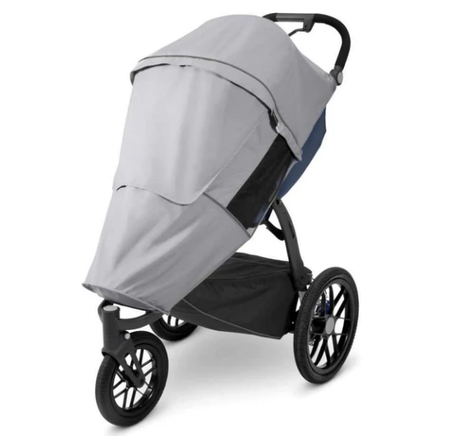

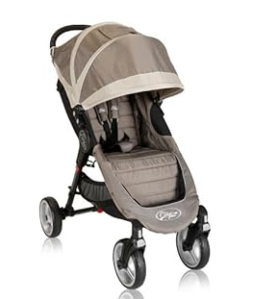

-Kellyleia. (2015, April 30). *Stroller Sun Shades - are they necessary?*. DIS Disney Discussion Forums - DISboards.com. https://www.disboards.com/threads/stroller-sun-shades-are-they-necessary.3405558/

-*Ridge Sun & Bug Stroller Shield: Snuggle bugz: Canada’s Baby Store*. Snuggle Bugz. (n.d.). https://snugglebugz.ca/products/uppababy-sun-and-bug-shield-ridge?gad_source=1&gclid=Cj0KCQjwurS3BhCGARIsADdUH50teTpiPS8MMkszkoIBHhnFucFGincqcuQwfk7Mwh5j0watEBOVzEEaAsOTEALw_wcB

-Include proper ventilation if its a full shade with mesh panels or windows to maintain airflow

Footrest

-adjustable & removable footrest for children allow for their feet to be planted rather then potentially dangling (when more grown up)

-reduces risk of dangling and getting stuck potentially

-another means of good posture and alignment

**Stability & Suspension**

Wide wheelbase &low center of gravity

-better stability from stroller tipping over, better center of gravity, essential on uneven tracks or fast maneuvers

-less likely to tip over,

-lower seat frame, baskets for storage are low as well

Suspension

-shock absorption for a smooth ride on uneven terrain, reduces vibrations and discomfort for a better, safer ride for the baby

-minimizes impacts of sudden movements

-suspension helps with heavier babies as well when going over rough terrain

-reduces strain on stroller frame providing longevity and makes it a longer worthwhile investment for parents

Different types os suspension

Front wheel suspension

-absorbs impact at front wheels where most shocks are felt

Full suspension

-better overall shock absorption, on both rear and front wheels

Air filled tires with suspension’

-combination of suspension system as well as tires filled with air to further reduce any shocks

Potentially add suspension systems similar to that of mountain bikes??

**Parent comfort**

Adjustable handle bar

-Allows parents of different heights to push strollers without any strain or reduced strain on back, shoulders, etc.

-neutral wrist position and better grip

-Handle bar should be made so that

-shoulders arent lifted around ears

-shoulders aren’t hunching forward

-around waist height (different for different heights)

Under stroller storage

-store essentials for child and possibly yourself

-make it adjustable height so easy access to it

-making it at a lower position allows for a lower center of gravity which allows for more stability

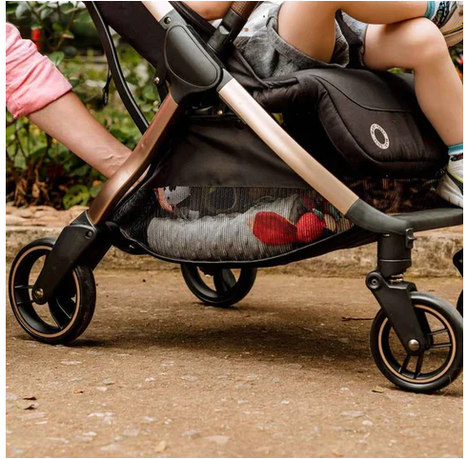

Picket&Rail Custom Sofas & Furniture. (2023a, June 10).

Lightweight & easy to move around

Strollers can be hard to use especially for the elderly and people with back issues etc.

-good materials (yee yin)

-having a lightweight easy to push stroller allows for move easier

-foldability ??? – might not be suitable for larger babies/when older

-Wheels - sb else researching this

**Citations**

*-Ergonomic strollers – confusion in definition*. Learn to Move. (n.d.). https://www.learntomove.se/en/project/ergonomiska-barnvagnar-definitionsforvirring/#:~:text=The%20key%20to%20sitting%20upright,from%20the%20front%20or%20back.

-Picket&Rail Custom Sofas & Furniture. (2023, June 10). *Baby Stroller - Top 20 must have features*. https://picketandrail.com/blogs/baby-kids-blog/the-top-20-best-baby-stroller-features#:~:text=An%20adjustable%20footrest%20is%20an,baby's%20 feet%20are%20 adequately%20supported.

-Roughan, A. (2023, August 3). *Stroller ergonomics for the parent*. Brain Under Construction. https://www.brainunderconstruction.co.nz/blog/2019/3/11/boundaries-8ml6t

-Picket&Rail Custom Sofas & Furniture. (2023a, June 10). *Baby Stroller - Top 20 must have features*. https://picketandrail.com/blogs/baby-kids-blog/the-top-20-best-baby-stroller-features#:~:text=An%20adjustable%20footrest%20is%20an,baby’s%20feet%20are%20adequately%20supported.